# SoftUni Forum Workshop - Part 1

This application is created as a workshop for the [Angular Corse](https://softuni.bg/trainings/3047/angular-november-2020) @ [Software University](https://softuni.bg)

# Task Requirements

You will be provided with skeleton (**HTML** and **CSS**). When starting the index.html, the following page will appear:

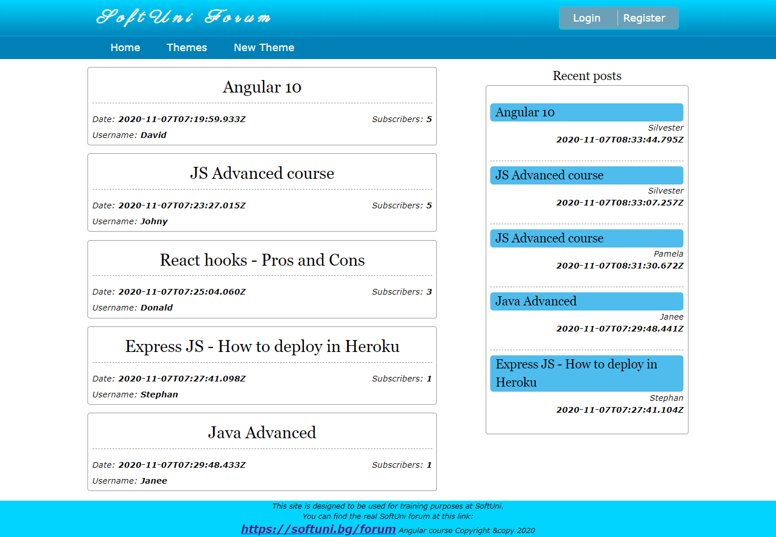

The application is a forum, where each registered user can create a theme or post a comment. For now, your task is to check the given skeleton (HTML and CSS files) and **split them into components**, so each part can be **reusable**. Be careful when you structure the components.

## MongoDB

Before you start with creating a new project in Angular you need to install **MongoDB and mongorestore**. You can find an installation guide in the provided document:

**MongoDB-Installation-Guide.docx**

(You might need to copy the content of the bin folder in mongorestore into the bin folder in MongoDB server and add the path to the folder "bin" in MongoDB server to the path variable from the system environment variables: https://www.c-sharpcorner.com/article/how-to-set-up-and-starts-with-mongodb/).

After the successful installation your database will be empty, so you can load the provided from us initial data in it as follows:

1. Download the provided folder named "forum".
2. In the console write the following command:

**mongorestore -d forum C:\Users\Name\Desktop\forum**

**Note* C:\Users\Name\Desktop\forum – replace with the path of the folder "forum" in your computer from the folder you are currently in! If you are in forum: ../forum**

On the console you will see something like this:

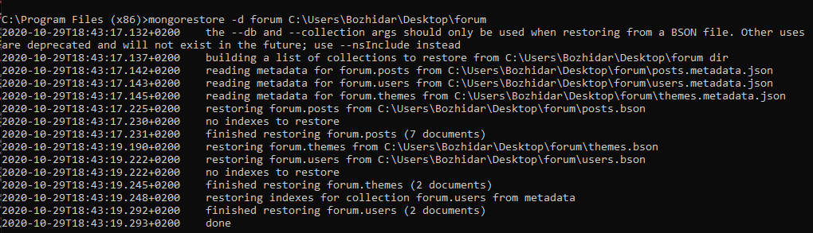

That's it! Now you can check if the db is in your dbs by the following commands:

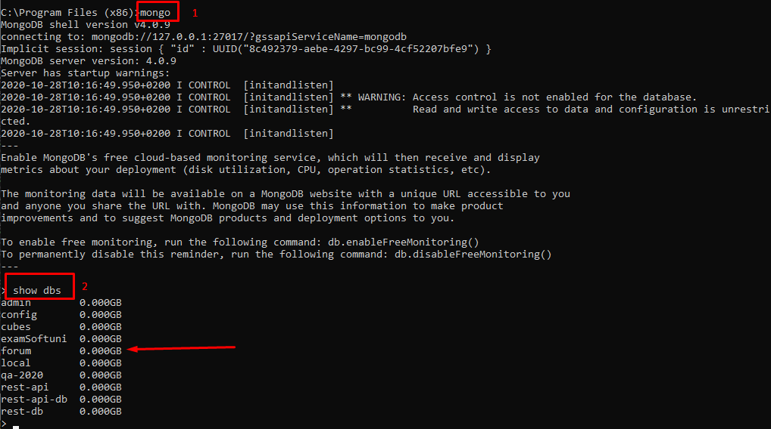

## REST API

You are provided also with **REST API**. To bring life on that API you should first install the dependencies with the command "**npm install**". After that, type the command "**npm start**". In order to fetch the themes, you will have to make a **GET** **request** on "**localhost:3000/api/themes**".

## Logged/Unlogged User

**NOTE: Because we haven't covered authentication yet (how to login and register), you can hardcode it with a variable.**

**Logged out** users see the **Login** and **Register** buttons/links.

## Implementation of the Main Section

After the backend is ready to use, you should **fetch all themes** and **list them** on the home page in the format you saw in the skeleton.

The **themes in the main** section should be **descending sorted by the subscribers**.

Each theme should have a **title**, **date** (when the theme is created), the **username** of the creator, **count of the subscribers** of the theme.

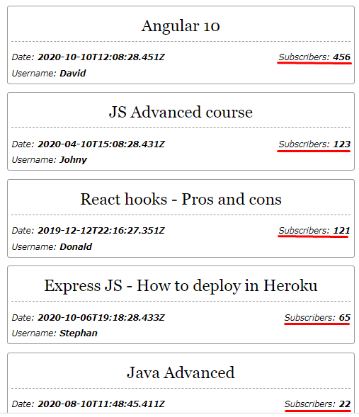

## Implementation of the Aside Section

In the **Recent posts section, only the 5 latest posts** must be shown! **(**[**https://localhost:3000/api/posts?limit=5**](https://localhost:3000/api/posts?limit=5)**)** The posts will be returned from the REST-api **sorted by the time of creation.**

Each component should have a **title (the title of the theme)**, a **username** of the user, whom the last comment in the theme belongs, and the **time** the post was created.

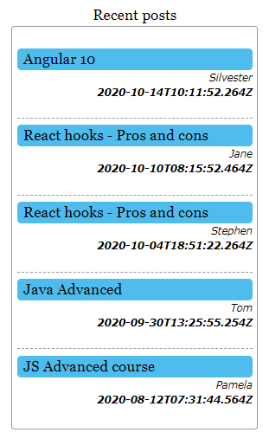

***GOOD LUCK*!**